[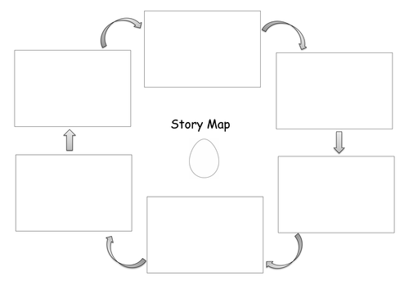](https://www.google.co.uk/url?sa=i&rct=j&q=&esrc=s&source=images&cd=&cad=rja&uact=8&ved=2ahUKEwjqs4aXwJLgAhWHlhQKHSJgD64QjRx6BAgBEAU&url=https://www.tes.com/teaching-resource/story-map-template-6421194&psig=AOvVaw3rz6cQ8IJLYLJUG5We5LV7&ust=1548834473179632)

**The Gingerbread Man**