Monday 10th January
Monitor my understanding of a text and be able to draw on a range of strategies to help me when needed.
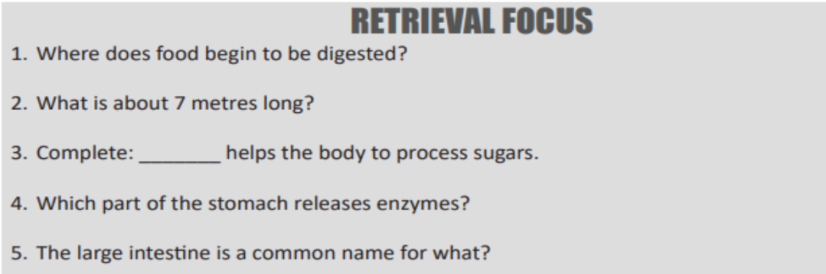

Monday 10th January
Monitor my understanding of a text and be able to draw on a range of strategies to help me when needed.

Monday 10th January
Monitor my understanding of a text and be able to draw on a range of strategies to help me when needed.

